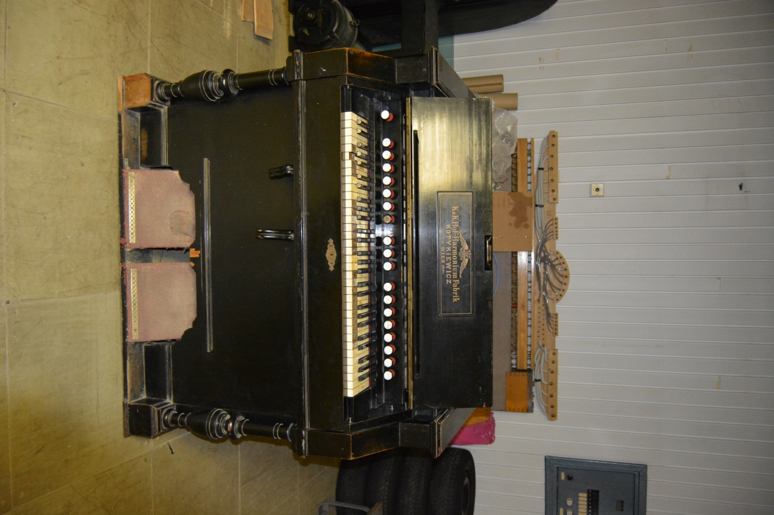**Harmonium Teofil Kotykiewicz Wien**

*No. 6891 – 5th June 1899*

*Karl Eduard Stradal*

*Teplice (nad Bečvou), Moravia (CZ)*

Disposition:

**P** PROLONGEMENT – AUTOMAT (C-d, 15 keys)

**F** FORTE

**6** AEOLINE 16´

**5** VOIX – CELESTE 8´

**4** BASSON 8´

**3** CLAIRON 4´

**2** BOURDON 16´

**1** COR – ANGLAIS PERCUSSION 8´

**S** SOURDINE

**E** EXPRESSION

**G** GRAND JEUX

**1** FLUTE PERCUSSION 8´

**2** CLARINETTE 16´

**3** FIFRE 4´

**4** HAUTBOIS 8´

**5** VOIX – CELESTE 8´

**6** AEOLINE 16´

**7** BARYTON 32´

**F** FORTE

Kneelevers:

Outer left: Cancelling Prolongement Automat

Inner Left: Forte (Bass+Treble)

Inner Right: Grand jeux (missing)

State:

Case is missing some veneers, left pilaster base plate is missing. Black shellac is scratched and missing on edges and lower parts around treadles. At some places new synthetic black finish was badly applied causing wrinkles and matt look. Brass parts are slighly oxidised and turning red. Left brass handle is broken and twisted (!). Grand jeux kneelever is missing. Carpet on treadles is not original and in bad shape, torn down. Felts are however dusty, but complete. Porcelain stop faces are rough on surface, letters are not visible with except of stop No. 4 Hautbois. Letters are (were) in older style than on most Kotykiewicz harmoniums. Keyboar from ivory is missing some white tops. I tis badly yellowed and stained by rust. Keyboar was luckily succesfuly cleaned by hydrogen peroxide and sun light.

Bellows are in good shape. Gasket between main windchest and bellow are leaking due to missing screws in hinge. Mowing the instrument throughout the years bended brass parts of stop action, although not causing serious damage. Top of reed pan on valve board is cracked. Percussion hammers are in great shape and working great. Reeds are not in tune, especially the No. 3 stop. Reeds are not coroded, but 12 reeds are broken in the middle of row No. 6 Aeoline 16´. In past, some broken reeds of Aeoline were (not professionaly) repaired by changing the tongues.

History:

There are two towns of Teplice in Czech countries, the book of instruments specify the „Tepliz im Mahren“ which are now called Teplice nad Bečvou. This is little spa town (originating spa history in medieval), however in the 1900s there was standing only one spa building and main development in 1930s, so the historic look of th town is no longer preserved.

Second big issue is the name of owner. This model is for sure not standartised. I tis way bigger than the biggest single manual instruments, which were advertised. Also the range of Prolongement Automat is bigger (from C to d). This make us think, that the instument was ordered by somebody with specific requirements for musical capabilities (note the case is much less ornate than instruments of same era). These instruments were very costly, so not everybody could order them. Search on internet found only one K. E. Stradal, lawer from wealthy family with connection to August Stradal, pianist and composer. This seems clear, but the family lived on the other side of Czech countries in the other Tepliz (=Teplitz-Schönau) and some members also worked and studied in Vienna.

To make this case more difficult, the instrument was somehow transported to Slovakia. We dont know why and when was this concert instrumen moved to the „world’s end“ on the border with hungary on the most east end of Slovakia. According to the last owner, whose grandmother bought this instrument (probalby damaged and covered in wax from candles) for her daughter to learn play, the previous location was in the nearby Monastery of Brehov. The small abby church has its own pipe organ on the small organ loft, so the harmonium probably was not used during the services. Could be standing on the floor in small nave, but most likely it was used in the buildings.

The monastery (of the Order of Smaller Brothers) was founded in 1419, the building and the abbey church are from 1769. During communist repression, monks were dismissed in 1950, monastery was decaying. Between 1959 and 1998 the sisters of st. Vincent were placed here by the authorities. Now the original order of st. Francis came back to the monastery and started the restorations.

The instrument was transported from nearby town Trebišov (Sk) transported to Třebíč (Cz) on 13th March 2019. Note the names of cities seem related despite beeing 550km apart.

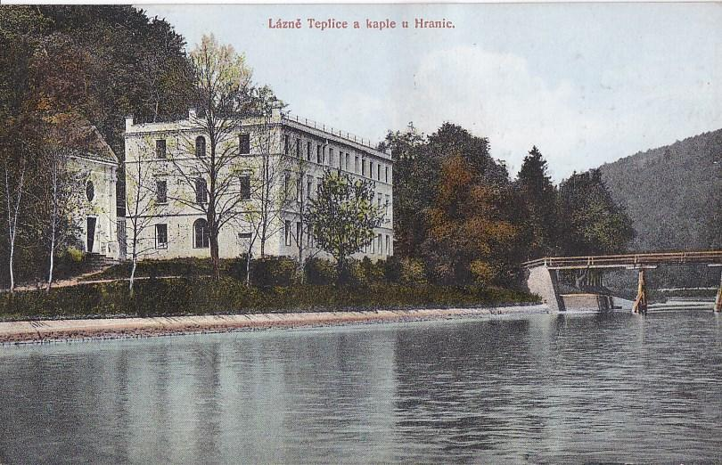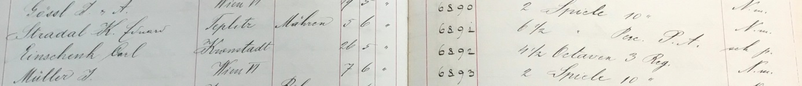

2 Teplice nad Bečvou in 1900s

1 The Book of instruments